when we define selection screens for our users, it's common practice to group certain fields together. And we can use these element blocks which will draw frames around the groups of fields we choose. We also have the option of adding frame labels.

As we look at element blocks, bear in mind that you can nest element blocks within other blocks, allowing you to subdivide individual sections of your screen.

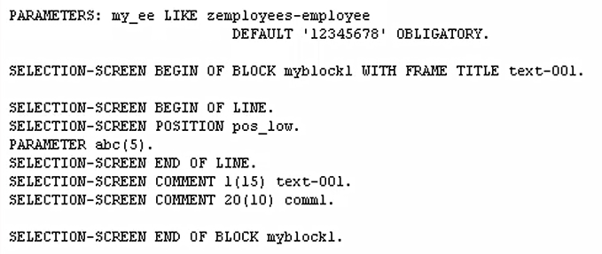

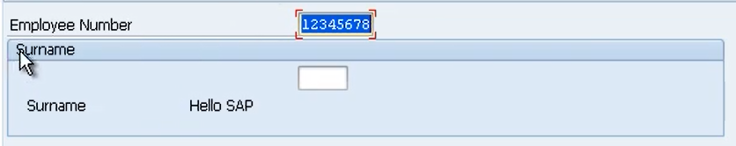

Now you have the option of choosing whether you want to apply a frame around a block of fields in your selection screen. We do that by using the width frame edition. So, let's add that in. So, all we do is type width frame.

now another addition is we can add a frame label. And we call these labels titles. So, we add a title to the frame. And as with comments we can use text symbols or field names with a maximum length of eight characters.

Now because we defined the start of a block, with the begin block addition. We also must remember to include an ender block.

Element blocks help give your field some context, and to help group your fields together.